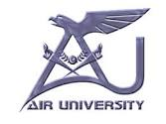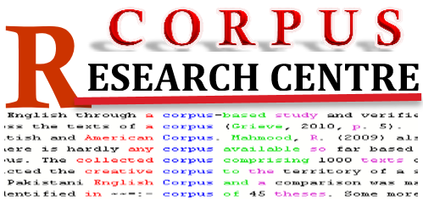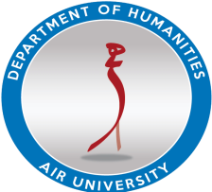
-----------------------------------------------------------------------------------------------------------------------------
Two-Days Hand-on Training Workshop on
Creating, Annotating and Analyzing Corpus for Pakistani Languages
Organized by
Corpus Research Centre
Faculty of Social Sciences, Air University
July 3rd and 4th 2017

Bio
Name:
Designation:
Qualification:
Affiliation:
Contact:
Email:

Why do you intend to participate in this workshop (120 words)

Enlist the workshops you attended/participated on corpus linguistics/computational linguistics

